### A STUDY ON ONLINE FOOD MANAGEMENT SYSTEM

Project submitted to Bharathiar University in partial fulfillment of the requirements for the award of the Degree of

**BACHELOR OF COMMERCE WITH COMPUTER APPLICATIONS**

**Submitted by**

1. **ALFIYA PARVEEN**

(Reg.No. 20BCC0008)

***Under the Guidance of***

**M. MUTHUSELVI M.Com., M.Phil.,**

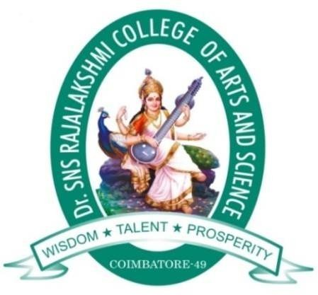 Assistant Professor, Department of Commerce with Computer Applications

### DEPARTMENT OF COMMERCE WITH COMPUTER APPLICATIONS

#### Dr. SNS RAJALAKSHMI COLLEGE OF ARTS AND SCIENCE (AUTONOMOUS)

**Accredited by NAAC (Cycle-III) with “A+” Grade Affiliated to Bharathiar University**

#### Coimbatore- 641049

**April- 2023.**